

Project: Mobile Application Development
Title: SelfPick E-Commerce Shopping

Group Members | Anus Imran (22-NTU-CS-1248)  M . Fahad (22-NTU-CS-1283)  Izaam Abid (22-NTU-CS-1268)
Class | BSSE(A)
Semester | 6th
Subject | Mobile Application Development
Course Code | CSE-4078L
Submitted to | Sir Rehan Sarwar

Department of Computer Science
Table of Contents
1 Title of the Project 1
2 Project Description: 1
2.1 Core Purpose : 1
2.2 Target Audience: 2
2.3 Key Features : 2
2.4 Expected Outcome : 2
3 Figma Design: 3
3.1 Splash Screen : 3
3.2 Sign In Screen : 4
3.3 Sign Up Screen : 5
3.4 Home Screen : 6
3.5 Cart Screen : 7
4 Screen/Pages with Description 8
4.1 Splash Screen 8
4.2 Sign Up Screen 8
4.3 Sign In Screen 8
4.4 Forgot Password Screen 8
4.5 Confirm Email Screen 8
4.6 OnBoarding Screen (Three Screens) 9
4.7 Home Screen 9
4.8 Store Screen 9
4.9 WishList Screen 9
4.10 Profile Screen 9
4.11 Cart Screen 9
4.12 Checkout Screen 10
4.13 Add New Address Screen 10
4.14 Confirm Order Screen 10
4.15 Product Detail Page Screen 10
4.16 Category Product Screen 10
4.17 Search in Store Screen 10
4.18 All Product Screen 11
5 Tools and Framework 11
5.1 Flutter (with Dart) 11
5.1.1. Why we choose Flutter 11
5.2 Firebase (Backend-as-a-Service) 11
5.2.1. Why we choose Firebase 12
5.3 Supporting Tools 12
5.4 Target Devices 12
6 Overall Summary of this Project 12
Table of Figures
Figure 1 : Splash Screen 2
Figure 2 : Sign-in Screen 3
Figure 3 : Sign-up Screen 4
Figure 4 : Home Screen 5
Figure 5 : Cart Screen 6

Proposal of the Project
Chapter 1

Title of the Project
The proposed project is titled "SelfPick (Click, Buy, Smile)", an innovative and user-friendly mobile e-commerce application designed to streamline the online shopping experience. The name "SelfPick" reflects the core concept of empowering users to conveniently browse, select, and purchase products directly from their mobile devices with just a few clicks. The tagline "Click, Buy, Smile" encapsulates our commitment to providing a seamless, satisfying, and joyful shopping journey. This project aims to deliver a smart, secure, and responsive platform tailored to meet the needs of modern consumers seeking efficiency, variety, and reliability in their online purchases.

Chapter 2

Project Description:
SelfPick (Click, Buy, Smile) is a mobile-based e-commerce shopping application aimed at delivering a seamless and efficient shopping experience. The app enables users to browse, select, and purchase products across various categories directly from their smartphones, promoting ease, speed, and satisfaction in the online buying process.

Core Purpose :
The primary purpose of SelfPick is to bridge the gap between users and a wide range of quality products by offering a reliable and accessible mobile platform. It is designed to cater to the growing demand for mobile shopping, especially among tech-savvy consumers who value convenience and speed.

Target Audience:
SelfPick targets a broad user base, including students, working professionals, and homemakers who prefer shopping online. It is tailored for users who expect a fast, organized, and secure mobile shopping interface with modern features.

Key Features :
- User registration and secure login
- Interactive product browsing and filtering
- Real-time product search and smart recommendations
- Product details with images, descriptions, and reviews
- Shopping cart and wishlist management
- Multiple payment options with secure gateway integration
- Order tracking and history
- User profile management and settings

Expected Outcome :
SelfPick aims to stand out as a modern and reliable mobile e-commerce solution, simplifying the online shopping process while enhancing user satisfaction through a clean UI, fast performance, and secure services.

Chapter 3

Figma Design:

Splash Screen :
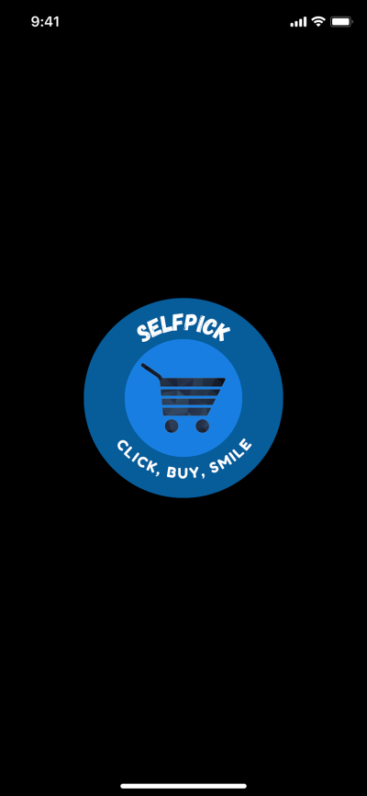
Figure 1 : Splash Screen

Sign In Screen :

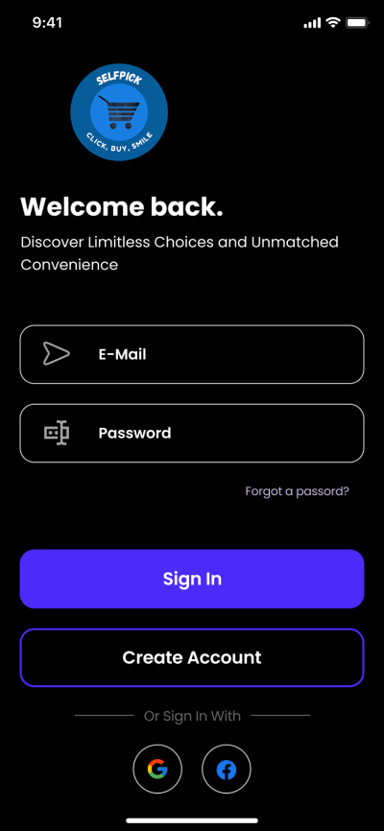
Figure 2 : Sign-in Screen

Sign Up Screen :
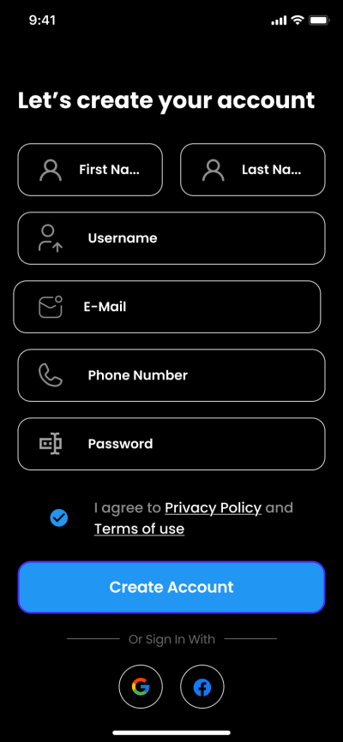
Figure 3 : Sign-up Screen

Home Screen :
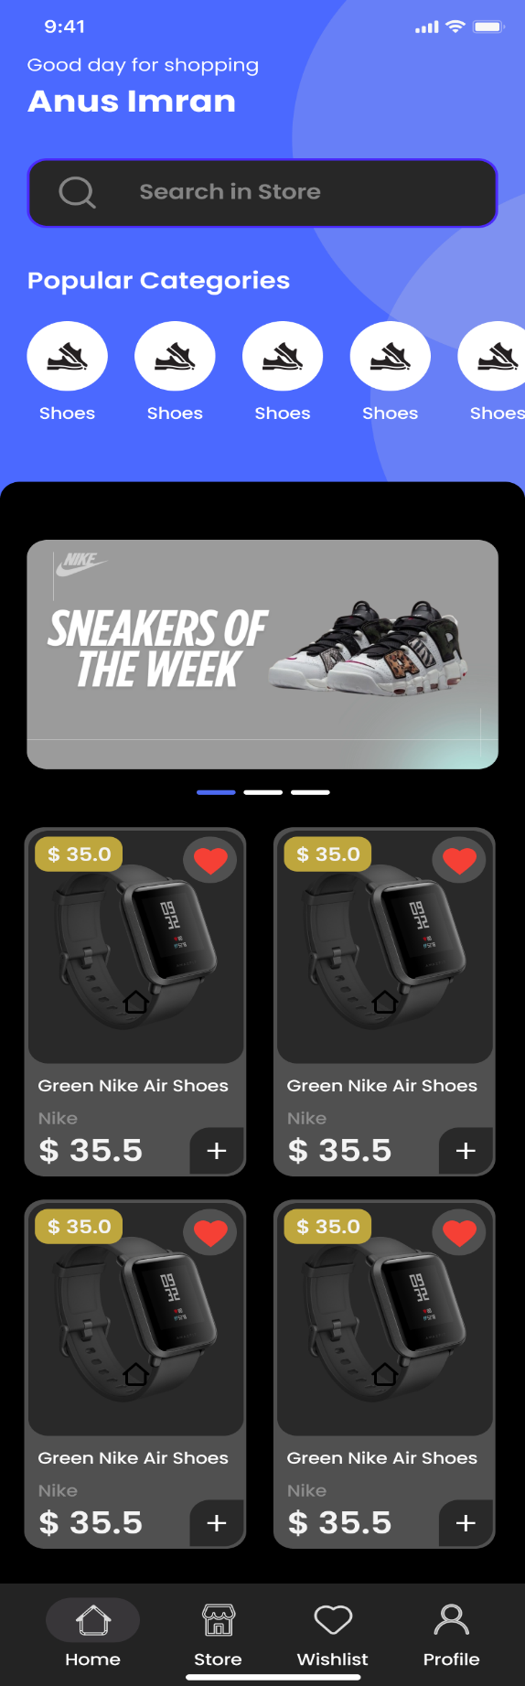
Figure 4 : Home Screen

Cart Screen :
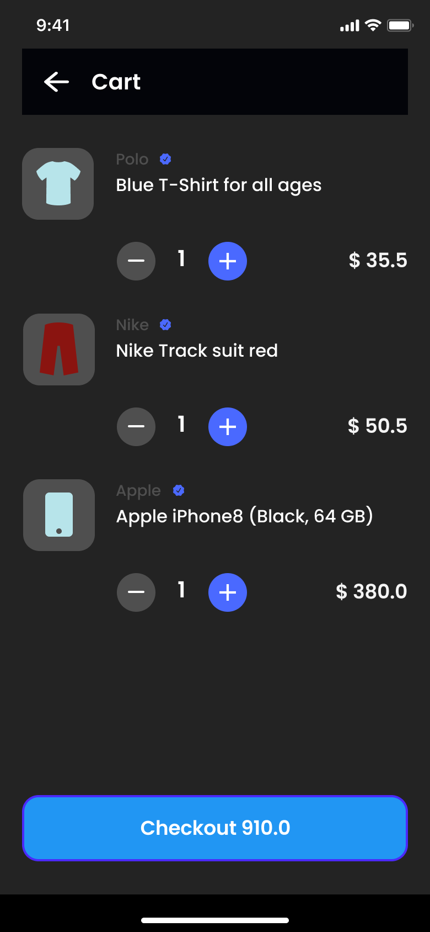
Figure 5 : Cart Screen

Chapter 4

Screen/Pages with Description
Below is a comprehensive list of screens/pages in the SelfPick (Click, Buy, Smile) mobile e-commerce application. Each screen is designed to ensure smooth user navigation, enhance the shopping experience, and support all necessary functionalities for both users and the business.

Splash Screen
This is the introductory screen that briefly appears when the application is launched. It displays the app logo and tagline, establishing brand identity and setting a welcoming tone. It enhances loading time aesthetics and builds anticipation before entering the main interface.

Sign Up Screen
This screen allows new users to create an account by entering essential information such as full name, email address, mobile number, and password. It ensures account security and enables a personalized shopping experience.

Sign In Screen
Enables existing users to securely log into their accounts using their registered email or mobile number and password. It may include options like "Remember Me" and "Sign in with Google/Facebook" for user convenience.

Forgot Password Screen
Facilitates password recovery for users who have forgotten their credentials. It allows users to reset their password through email or mobile number verification, ensuring account accessibility without compromising security.

Confirm Email Screen
During the sign-up process, users are required to verify their email address. This screen prompts users to enter a verification code or click on a link sent to their email, helping prevent spam accounts and ensure authenticity.

OnBoarding Screen (Three Screens)
A sequence of interactive and visually engaging screens that introduce new users to the key features of SelfPick. These screens highlight the app’s value propositions such as secure shopping, diverse product availability, and user-friendly navigation.

Home Screen
Serves as the main dashboard of the application. It displays featured products, promotional banners, deals of the day, and major product categories. It provides shortcuts to search, cart, profile, and other core sections of the app.

Store Screen
Displays a full range of product categories and featured brands. Users can browse different departments like fashion, electronics, and home goods. This screen is structured to help users quickly find products relevant to their needs.

WishList Screen
Allows users to bookmark products they are interested in but not ready to purchase immediately. This feature improves user retention and helps track preferences for future purchases.

Profile Screen
Displays user-specific information including name, email, saved addresses, and order history. It offers options for editing personal details, changing passwords, managing addresses, and logging out.

Cart Screen
Lists all the products added by the user for purchase. It includes quantity selectors, price details, and options to remove items. Users can review their selected items before proceeding to checkout.

Checkout Screen
A summary page where users review their cart, select/add delivery addresses, choose payment methods, apply discount codes (if available), and place the final order. It ensures a smooth and secure transaction process.

Add New Address Screen
Provides a form for users to enter a new delivery address, including fields for name, mobile number, street, city, postal code, and optional notes. Addresses are saved for future orders to improve efficiency.

Confirm Order Screen
This confirmation screen appears after a successful purchase. It displays the order ID, estimated delivery time, and a summary of the order, giving users confidence that their transaction was successful.

Product Detail Page Screen
Displays in-depth information about a specific product. This includes high-resolution images, price, available sizes or variations, product description, specifications, customer ratings, and reviews to aid decision-making.

Category Product Screen
Shows all products under a selected category, such as "Men's Clothing" or "Mobile Accessories." It helps users explore items grouped by interest or purpose, streamlining product discovery.

Search in Store Screen
Offers a powerful search tool that allows users to find specific products using keywords. Includes filters for category, price range, brand, and ratings, helping users quickly locate what they need.

All Product Screen
Displays the full catalog of products available on the platform. This screen ensures users have access to the complete range without any filtering, ideal for casual browsing.
Chapter 5

Tools and Framework
To ensure a modern, scalable, and high-performance mobile application, the SelfPick (Click, Buy, Smile) e-commerce app leverages the following tools and frameworks:

Flutter (with Dart)
Flutter, developed by Google, is a cross-platform mobile application development framework that uses the Dart programming language. It provides a robust, modern solution for building high-quality apps from a single codebase.

Why we choose Flutter
- Fast development with hot reload
- Rich and customizable widgets
- Cross-platform compatibility (iOS & Android)
- Smooth UI rendering and animations

Firebase (Backend-as-a-Service)
Firebase, also from Google, is a Backend-as-a-Service (BaaS) platform that offers real-time database services, authentication, cloud storage, push notifications, and more — all of which are essential for an e-commerce mobile app.

Why we choose Firebase
- Authentication: Secure sign-up, sign-in, and password recovery
- Cloud Firestore: Real-time NoSQL database to store user data, product information, and order history
- Firebase Storage: For storing product images and other media
- Firebase Cloud Messaging (FCM): For sending push notifications about promotions, orders, and updates

Supporting Tools
Android Studio / Visual Studio Code:
- Primary IDEs for coding and UI development
- For writing, testing, and debugging the Flutter application.

Target Devices
The app is developed and optimized for Android devices including:
- Realme 5i
- Vivo Y20
Chapter 6

Overall Summary of this Project
SelfPick (Click, Buy, Smile) is a modern e-commerce mobile application built to offer a smooth, secure, and user-friendly shopping experience. From easy onboarding to product discovery, checkout, and order tracking — every step is designed for convenience and speed.
Developed using Flutter and Firebase, the app delivers strong performance, real-time data handling, and cross-platform support. It features user authentication, product catalog browsing, cart and wishlist management, and personalized user profiles — all within a clean, responsive interface.
This project emphasizes usability, scalability, and functionality, aiming to simplify online shopping and bring smiles with every click.

